JAVA MINI PROJECT

# TERNA ENGINEERING COLLEGE, NERUL

# TOPIC – CURRENCY CONVERTER

### MADE BY-

### RUCHA TIRODKAR (B-24)

**PROBLEM STATEMENT**

Help the user to convert currency from RUPEE /YURO/DOLLAR/YEN/POUND and display the result in all other types of currency.

**INTRODUCTION**

Currency converter (or currency exchange) is a mini project coded in Java programming language. This simple application provides a web-based interface for exchanging/converting money from one currency (say $) to another currency (say €).

In this currency converter app, users are provided with an option to select the type of currency. This simple feature allows users to enter amount to be converted and display the converted amount in all other type of currencies.

**Currency Converter Abstract**

Different countries use different currency, and there is daily variation in these currencies relative to one another. Those who transfer money from one country to another (one currency to another) must be updated with the latest currency exchange rates in the market.

Currency converter mini project is built keeping this thing in mind. It is simply a calculator-like app developed using Ajax, Java service. In this application, there is regular update about currency of every country by which it displays present currency market value and conversion rate. Such application can be used by any user, but it is mainly useful for business, shares, and finance related areas where money transfer and currency exchange takes place on a daily basis.

**Proposed System**

The proposed system is better and more efficient than existing system by keeping in mind all the drawbacks of the present system to provide a permanent solution.

The primarily aim of the new system is to speed up the conversion messages and display it to make it more user friendly.

**FLOWCHART**

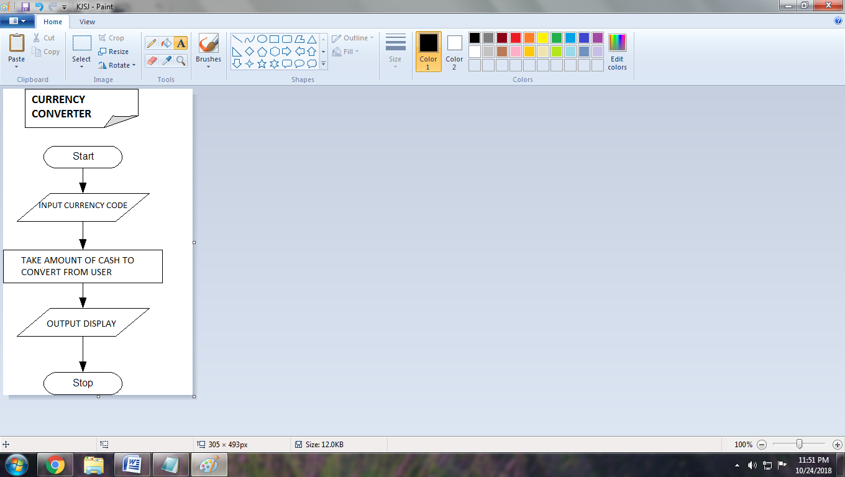

**OUTPUT SCREEN**

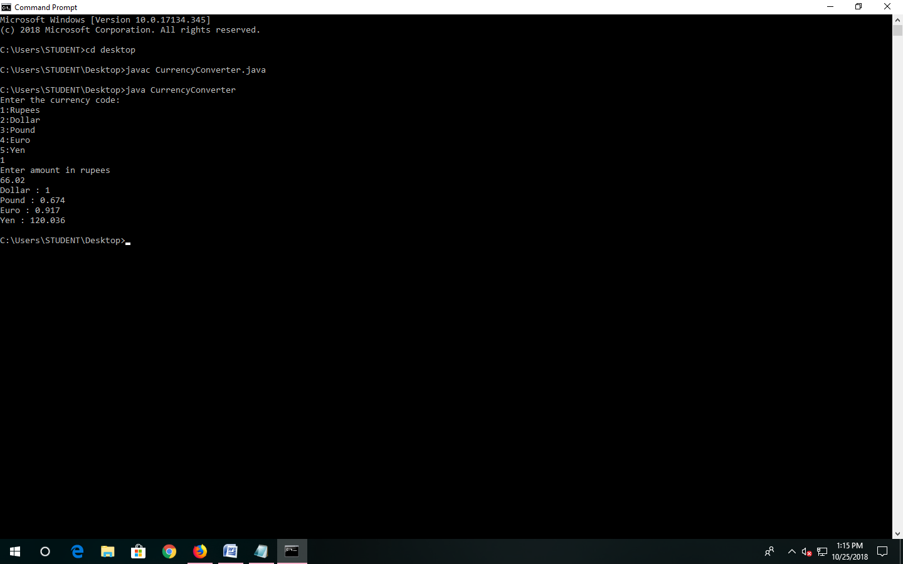

**CONCLUSION**

Hence we are able to make an user friendly currency converter. This also helps in reducing the time required for currency conversion and we get accurate up to date information about currency rate.